1.

341

2.

original: %)@$

base-8: 1360

decimal: 752

3.

(a)

0xd9c8

(b)

1011_0000_1101_1110_1111_1010_1100_1110

4.

(a)

1023

(b)

00001111+11101110 = 11111101

result = - $2^{7}$ + 0b01111101 = -128 + 125 = -3

(c)

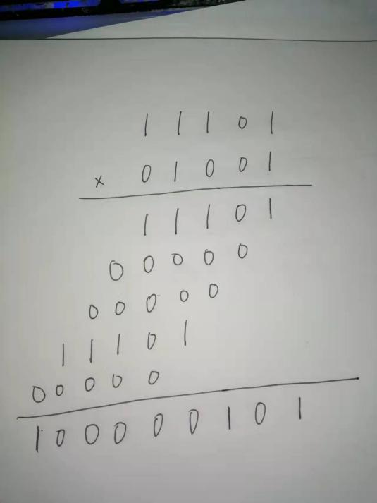

result = 261

5.

the third: 1111 + 0111

the fourth: 1110 + 1101

6.

|  |  |
| --- | --- |
| decimal | binary |
| 229 | 11100101 |
| 32 | 100000 |

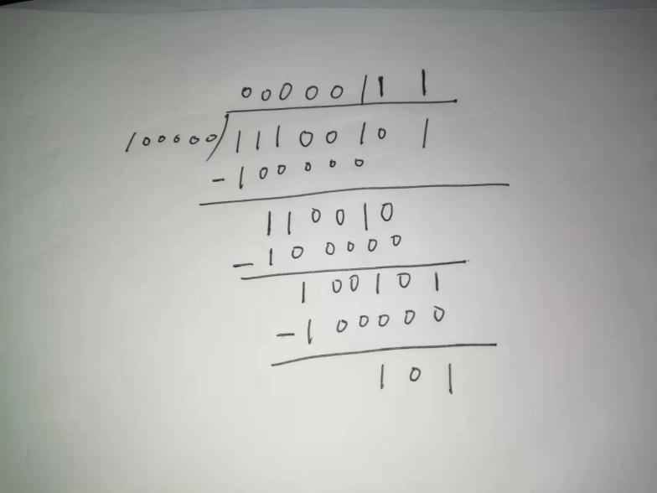

result = 111.00101

7.

Step 1:

4.75(decimal) = 100.11

Step 2:

100.11 = 1.0011 x ($2^{2}$)base10, exponent is ( 2+3) base10 = 0b101

Step 3:

1.0011=1.0011, mantissa is 0011.

there is no need to add tailing zero, because there are only 4 bits in mantissa.

Step4:

its sign bit is 1

|  |  |  |
| --- | --- | --- |
| sign | exponent | mantissa |
| 1 | 101 | 0011 |